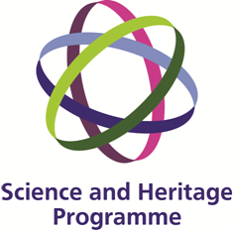
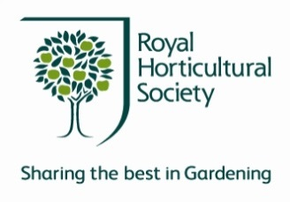

Culture and Trade through the Prism of Technical Art History- A Study of Chinese Export Paintings

Workshop II

Victoria & Albert Museum, Hochhauser Auditorium

Monday 9th December 2013

10.00-10.05 | Welcome
10.05-10.30 | Chinese export pictures and the RHS Reeves Collection: motivation, manufacture and meaning  Kate Bailey V&A, Charlotte Brooks RHS
10.30-11.00 | A holistic approach to non-invasive investigation  Haida Liang NTU, Lucia Burgio V&A
11.00-11.20 | Coffee break
11.20-11.30 | Displaying Chinese export watercolours: microfade & light sensitivity  Andrei Lucian NTU
11.30-11.45 | Seeing through the paintings: OCT, underdrawings & paper classification  Haida Liang NTU
11.45-12.25 | Pigment identification with Raman & XRF  Lucia Burgio, Sonia Bellesia V&A
12.25-12.50 | Multispectral imaging, FORS, pigments and the painting techniques  Andrei Lucian, Haida Liang NTU
12.50-2.00 | lunch
2.00-2.30 | A glimpse of the Asian artisan’s materials and techniques through the paintings of Mogao caves (4th -15th century)  Bomin Su, Dunhuang Academy
2.30-3.00 | The European artist’s palette in the nineteenth century: pigments for watercolour and oil painting  Jo Kirby, National Gallery
3.00-3.20 | Shipping colour: The East-West paint and pigment trade  Kate Bailey, V&A
3.20-3.40 | Tea break
3.40-4.05 | The conservation of three Chinese export oil paintings  Margrit Reuss, Rijksmuseum Volkenkunde
4.05-4.30 | ‘The Lotus springs from the mud': conservation of a Chinese export wallpaper  Susan Catcher V&A
4.30-5.00 | Panel discussion: What do scientific analyses tell us about cultural exchange & art history?
For further details, see the project website:
http://www.ntu.ac.uk/apps/research/groups/22/home.aspx/project/144043

