Taster Example: YAMMER
What is it?  A social media platform that comes as part of Office 365 and is available to both staff and students. | Find more Help online:  Office Central Learning Room: http://bit.ly/1FGC5rL  Yammer Guides including for teaching (in Office Central): http://bit.ly/29gzyA4  For further resources including guides, videos and more, please access the Yammer padlet: https://padlet.com/mjhomewood/yammer

Link to Digital Framework Areas of Practice
- Communication and Collaboration
  - Use digital technologies to participate in/manage networks
  - Use digital technologies to share, co-share and disseminate knowledge
  - Manage appropriate levels of privacy
  - Manage digital identity and reputation
- Learning to Learn
  - Use digital networks and online resources to fit learning into life/work
  - Access support online including self-supporting communities
- Learning Technologies
  - Choose technologies appropriate to learning activity
  - Design online activities, e-moderating
- Information Literacy
  - Rate, comment on and review resources online
  - Share, repurpose, enrich information resources in online communities
- Digital Identity and Employability
  - Use digital technologies to present self and manage reputation
  - Understanding digital rights and responsibilities
  - Manage issues of privacy and data ownership
  - Understand moral and human rights in a digital context
  - Understanding digital rights and responsibilities
  - Manage issues of privacy and data ownership
  - Understand moral and human rights in a digital context
  - Understand issues around safety and protection in a digital context

Taster Example: VOTING SYSTEMS
What is it?  Voting systems, either via a handset or online/mobile device, provide ways to encourage students to become active participants in teaching sessions. | Find more Help online:  Technology Central Learning Room: http://bit.ly/1QI9mbk  Voting Systems (in Technology Central Learning room):  http://bit.ly/298F5V6

Link to Digital Framework Areas of Practice
- Communication and Collaboration
  - Engage in computer supported collaborative working
- Learning to Learn
  - Diagnose learning needs
- Learning Technologies
  - Choose technologies appropriate to learning activity
  - Design online activities, e-moderating
  - Design online e-Assessments
  - Design online Submission/peer marking and Feedback of assessments/activities
- Computer Literacy
  - Choose and use a range of different tools as appropriate to the situation
  - Capture information and evidence digitally

Taster Example: PADLET
What is it?  An online virtual wall allowing individuals to share thoughts/ideas on a particular topic. | Find more Help online:  https://padlet.com/  Active Learning Activity – TIPS NOW Learning rooms: http://bit.ly/29kz9ec  Tools to Enhance and Extend Classroom Learning (CADQ Guide): http://bit.ly/29dbTAa

Link to Digital Framework Areas of Practice
- Communication and Collaboration
  - Use digital technologies to participate in/manage networks
  - Use digital technologies to share, co-share and disseminate knowledge
  - Engage in computer supported collaborative working
- Learning Technologies
  - Choose technologies appropriate to learning activity
  - Design online activities, e-moderating
  - Design online e-Assessments
- Information Literacy
  - Aggregate and re-aggregate information on task/topic basis
- Computer Literacy
  - Choose and use a range of different tools as appropriate to the situation

Taster Example: NOW WIDGETS
What is it?  NOW widgets can be used to expose a range of NOW functionality and external apps in a learning room homepage. | Find more Help online:  NOW Central:  https://goo.gl/t07Jcn  Toolkit- Providing Information with NOW (in NOW Central)  http://bit.ly/29j7Bod  Moving Forward with NOW Programme (via CPLD):  http://bit.ly/29b0gVz

Link to Digital Framework Areas of Practice
- Communication and Collaboration
  - Use digital technologies to share, co-share and disseminate knowledge
- Learning Technologies
  - Online creating/sharing of resources to support learning
  - Choose technologies appropriate to learning activity
  - Using learning design tools to develop courses
- Information Literacy
  - Aggregate and re-aggregate information on task/topic basis
  - Use digital tools to manage information locally and remotely
- Media Literacy
  - Understand how digital media work in terms of audience, viewpoint, design
  - Produce messages in a range of digital media
- Computer Literacy
  - Choose and use a range of different tools as appropriate to the situation
- Digital Identity and Employability
  - Understanding digital rights and responsibilities
  - Manage issues of privacy and data ownership

Taster Example: OMG Word & Excel
What is it?  Office 365 encompasses all the familiar Microsoft Office programs with the added benefit of using them online. | Find more Help online:  Technology Central Learning Room: http://bit.ly/1QI9mbk  Office Central Learning Room :  https://goo.gl/xN9LtU  Digital Practice Blog:  http://goo.gl/2O4FNd

Link to Digital Framework Areas of Practice
- Communication and Collaboration
  - Use digital technologies to share, co-share and disseminate knowledge
  - Engage in computer supported collaborative working
- Learning Technologies
  - Online creating/sharing of resources to support learning
  - Using learning design tools to develop courses
  - Use digital data analysis tools and protocols to analyse learners progress
- Information Literacy
  - Use digital data analysis tools and protocols
  - Share, repurpose, enrich information resources in online communities
- Computer Literacy
  - Choose and use a range of different tools as appropriate to the situation
  - Capture information and evidence digitally
- Digital Identity and Employability
  - Understanding digital rights and responsibilities
  - Manage issues of privacy and data ownership

How to Access NOW Learning Rooms:
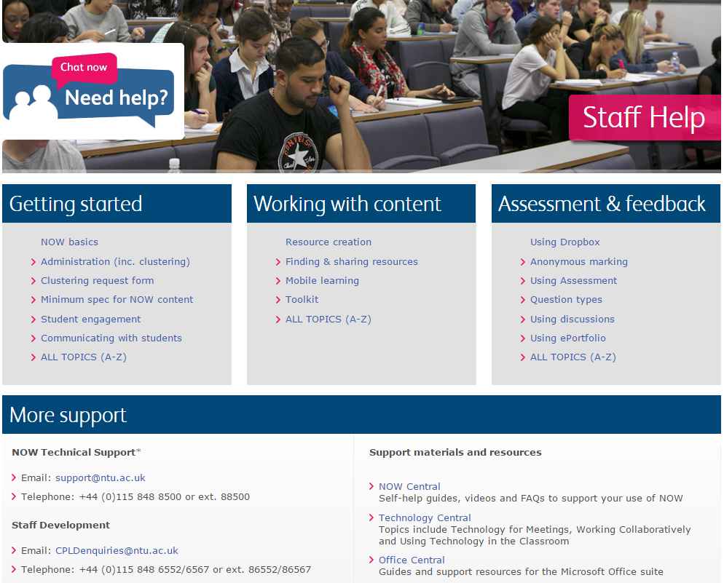
You can find loads of additional resources on the various technologies presented today via the OFFICE CENTRAL, NOW CENTRAL and TECHNOLOGY CENTRAL NOW learning rooms – Log into NOW, click on Help and then click on the relevant support materials or resources.

