OMG I didn’t know it could do that…..Some Office Tips for you & your students
- Format Painter
You know when you copy something into Word and all formatting goes wonky your bullets points move at random or you delete a line and all of a sudden you drop into Times New Roman font ……
This is the quick way to sort this
- Select the text that’s got the correct format
- From the home menu bar at top of screen select the paint brush
- Apply it to the troublesome text and
- Voila it’s done
From this
- Organisational and interpersonal skills
- Addressing the needs of individuals
- Time management skills
- Working in a challenging and unpredictable environment
- Staff responsibilities and conduct
  - The ability to improvise
  - Giving (and taking) feedback
  - Handling difficult and potentially disruptive situations
  - Public speaking and communication skills
  - Team-working
  - Standard teaching methods
To this
- Organisational and interpersonal skills
- Addressing the needs of individuals
- Time management skills
- Working in a challenging and unpredictable environment
- Staff responsibilities and conduct
- The ability to improvise
- Giving (and taking) feedback
- Handling difficult and potentially disruptive situations
- Public speaking and communication skills
- Team-working
- Standard teaching methods

- Auto Fill and Flash Fill in Excel
Auto Fill & Flash fill in excel see on line tutorial at Digital Practice Blogs (http://blogs.ntu.ac.uk/digital_practice/2015/04/27/office-tips-and-tricks-autofill-and-flash-fill-in-excel/)
Autofill
For copying formula down a column of data
- Select cell go to bottom right of cell until a + appears ,
- drag down the + down the column
- This copies your formula to all cells in the column adjusting/updating cell references as it goes
- You can do 5 or 300 students all at once…
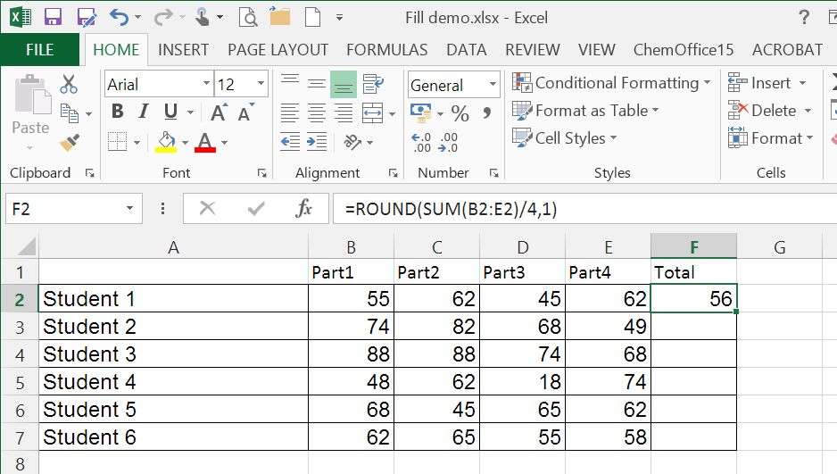
+

- Flash Fill
You know how it is trying to compile your module spreadsheets and people give you their marks in different formats for their groups
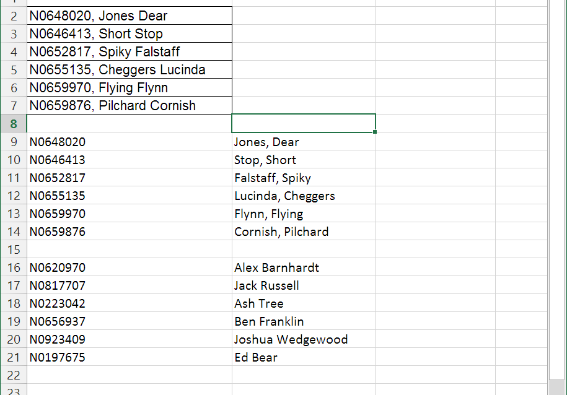
However you no longer have to retype the data –
Excel 2013 has a Flash fill command in the Data header
- Go to an empty cell in the column next to your data
- Type in first cell or two the format you want your entry in then hit Flash Fill and it will suggest the format of the rest of the column
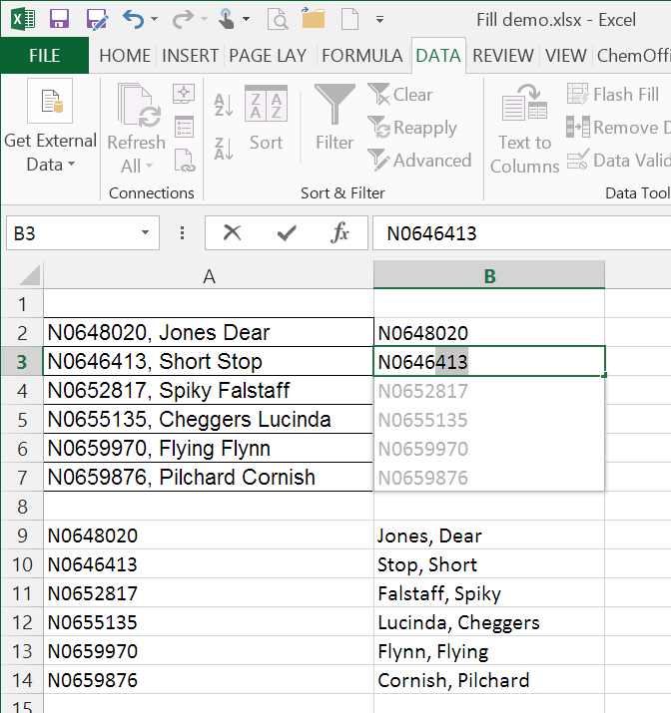
- Press enter to accept
If you want to split up names and numbers you can do this too…
Just give excel some examples of what you do want and either it will suggest what it thinks you want or you need to use the Flash Fill tool
