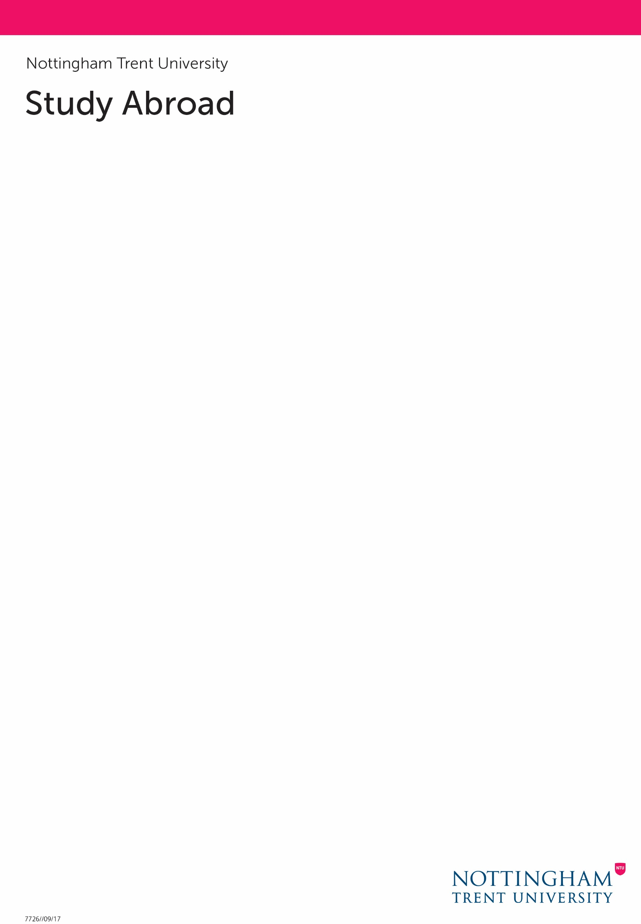

**Karlsruhe Cultural Festival Video Competition**

**About the project:** NTU Global are looking for students from any NTU course (including Confetti) to produce a short video responding to the question: *"What does Europe mean to me?"* We want you to think about what Europe means to you and how this might have influenced your own identity. Perhaps you feel part of a big family at NTU and enjoy its values and diversity? Europe could mean the opportunity to travel, meet new people from different cultures and learn new languages. All these ideas and more can be explored within your video.

**Who can apply?** Students can work as an individual or as a group of up to 4 students. This question could be answered by you or other students, NTU colleagues or the community of Nottingham. The video could include footage of students in dialogue, a face to face to camera or a creative/abstract response.

**Why should I apply?** A panel of 3 judges from NTU and the Creative Quarter will judge the entries and select one lucky winner to showcase their video at the Karlsruhe Cultural Festival on 5 May 2020. The winning prize will include the cost of flights, accommodation and up to £200 spending money to stay in Karlsruhe in Germany (Nottingham’s twin city) for two nights (5 and 6 May). Please check that the dates of the festival do not clash with exam dates.

**Permissions:** Students will be provided with copyright and consent forms. The copyright forms are to evidence permissions obtained for any third-party images/music used and the consent forms are for all film participants to complete. Please ensure that all completed consent forms are placed in a secure location until delivered to the City Global Lounge between Monday 16 – Friday 20 March where we will securely store this data.

**Deadline to apply:** The deadline to submit your video is **Monday 16 March 2020** via We Transfer ([www.wetransfer.com](http://www.wetransfer.com)) to: [NTUGlobal@ntu.ac.uk](mailto:NTUGlobal@ntu.ac.uk) Please make sure all video content is submitted in HD or HD264 format and that the duration is between 2 – 3 minutes. For further information please email: [NTUGlobal@ntu.ac.uk](mailto:NTUGlobal@ntu.ac.uk)