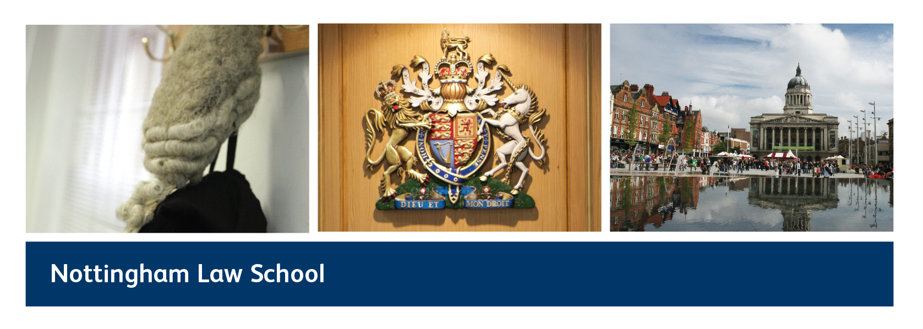

Your Future, Your Legal Career
Wednesday 13 November 2013
Conference Report

There are so many changes hitting the legal profession that it is hard for students to keep up to date and to appreciate what these changes might mean for them. The recommendations from the Legal Education and Training Review research phase (“LETR”) are only a starting point in the debate about the future of legal education, whilst the introduction of Alternative Business Structures (“ABS”) makes it less clear as to what undergraduate and Graduate Diploma in Law (“GDL”) students might expect should they decide to enter the solicitors’ or barristers’ profession.

This conference, which was hosted by Nottingham Law School in conjunction with the University of Nottingham, sought to try and shine a light in the darkness and to show undergraduate and GDL students what it means to be in legal practice today.

Following an introduction from Professor Andrea Nollent, Dean of Nottingham Law School in which she welcomed the delegates and visitors from other law schools, the conference began with an overview of the changes envisaged by the LETR research phase from Professor Jane Ching. Professor Ching was followed by Alan Sinnett, a partner at Shakespeare’s Solicitors, who spoke of his own career in law, the realities of the solicitors’ profession today and the future he saw for the current crop of students. The conference was rounded off by a panel discussion, made up of solicitors, barristers and careers advisers and was chaired by Paula Moffatt, Principal Lecturer at Nottingham Law School.

A film of the conference will shortly be made available on our website so that it will be possible to watch each session. In the meantime, this report sets out a snapshot of the discussions that took place on the day and can also be viewed with Professor Ching’s slides which have been posted on our website.

Session 1
Chair: Professor Becky Huxley-Binns, Professor of Legal Education, Nottingham Law School

Overview of LETR
Professor Jane Ching, Professor of Professional Legal Education, Nottingham Law School,
LETR research team member

In this session, Professor Ching illustrated the different types of “law jobs” that exist, some of which law students may know very little about. She explained the difference between the eight legal professions regulated under the Legal Services Act 2007 and the unregulated parts of the legal services sector and suggested to students that they may want to try and think about what their niche might be.

In her discussion of the LETR research phase conclusions and recommendations, Professor Ching reiterated that LETR is only just the beginning of the process of change to legal services education, which is at least two years away. The regulators who commissioned the LETR research phase (the Solicitors’ Regulation Authority (“SRA”), the Bar Standards Board and ILEX Professional Standards) are in the process of responding to the LETR recommendations, with the SRA already carrying out work on a set of “day one” competences representing what solicitors should be able to do at the point they qualify and the BSB making changes to the regulation of barristers’ chambers which supervise pupils.

Session 1
Chair: Professor Becky Huxley-Binns, Professor of Legal Education, Nottingham Law School

The legal profession in 2013 – what it means for students
Alan Sinnett, Partner and Regional Head of Shakespeare's South West Midlands Practice

In a highly entertaining and personal reflection on his own career as a solicitor in a Midlands practice, Alan discussed how important hard work and determination had been in achieving his goals. He recommended the law degree as one of the most useful degrees that a student could do – simply for itself - but was cautious about the prospects for students wishing to train as solicitors or barristers.

Referring to the legal press, he explained to students that law firms were struggling to survive financially: much damage had been done to their business in the fall out from the banking crisis that began in 2007 with the collapse of Northern Rock and, since then, recovery had been very limited. Cost have been driven down so that firms cannot support a “top heavy” partnership structure. These days, a more typical law firm structure is one where a partner, working with perhaps two senior associates, oversees the work of a team of thirty or so people who undertake most of the client related work.

Despite the challenges of the market place, Alan nonetheless exhorted students to aim high and to be aspirational. Any student who wanted to be a solicitor should still aim to become one. However hard it had been for him in achieving his goal, he had always known that there was nothing else that he would rather be.

Session 2
Chair: Paula Moffatt, Principal Lecturer at NLS and Solicitor

Round table discussion on the implications of the LETR and other changes to the profession

Panellists:

Alan Sinnett, Partner and Regional Head of Shakespeare's South West Midlands Practice

Alexia Binns, Solicitor, HW Martin, Executive Committee Member of the Law Society Junior Lawyers Division

Catarina Sjolin Knight, Senior Lecturer at NLS and Barrister; Door Tenant at 36 Bedford Row, London

Andrew Pike, Assistant to Paul Bleasdale QC at No5 Chambers

Peter Kay, Senior Careers Consultant, University of Nottingham

Alexia Binns, an NLS LPC alumna, began by explaining how she had trained with a High Street firm of solicitors which had given her a well rounded view of the work a solicitor can do. This had been invaluable when she moved into practice as an in-house lawyer as it had given her a degree of flexibility to address a wide range of contentious and non-contentious problems.

Catarina Sjolin Knight discussed the present position of the criminal bar: students need to be aware that there is almost no publicly funded work available. She reiterated the importance of students focusing on what kind of work they would enjoy doing and then consider the ways in which they could achieve that outcome. Students should undertake proper research when applying for jobs. It was very important to aim high, but she also stressed that students should have a fall back position.

Andrew Pike, an NLS GDL and BPTC alumnus, explained how difficult it was to obtain pupillage and how pleased he had been to get para-legal work and so get his “foot in the door”. When applying for roles, he had used his BPTC exam results to demonstrate to employers how good he was at the particular legal skills they required for the job advertised. He considered that, although Pro Bono work was useful in terms of building a CV, most people could not afford to work without pay and so he had had to get para-legal work to pay his bills.

Peter Kay and Alan Sinnett reflected on the difference in perspective of the City firms. These firms are well funded as they undertake international work and so operate on a different model from most firms outside London and the South East. The City market is, therefore, a highly specialist one. Not all students may choose to enter into it, as although the salaries may be high, trainees and associates are set a high number of target billable hours and the work life balance can be challenging.

In the context of a discussion around “law jobs”, Paula Moffatt noted a significant point, made by Alan Sinnett and touched on by Alexia Binns, about the importance of maintaining one’s reputation as a lawyer. Being a solicitor or barrister was about more than just doing a job: honesty and integrity were crucial elements in the role of the “trusted adviser” that society has traditionally viewed solicitors as being.

She also noted that there tended to be much discussion around the concept of “commercial awareness”, but less around the concept of “social awareness”. Students need to be mindful of the fact that not all clients will come from a commercial background: a lot of legal work is based on understanding the personal situation of those on welfare benefits. In this part of the legal sector, social awareness is just as important a legal skill as that of commercial awareness.

The speakers were warmly thanked for participating in the conference and the audience thanked for their questions and contributions to the debate.

Conference conclusions

Reiterating the introductory remarks made by Professor Andrea Nollent, Paula Moffatt summed up some of the conclusions from the conference:

- There are jobs out there for law students, but they may be jobs that they have not previously thought about and that exist beyond the traditional jobs of solicitor and barrister. There may even be future law jobs out there of which we cannot yet conceive (think Facebook – it didn’t exist in the way we know it today even 10 years ago).

- Students need to try and focus on what is the kind of job or the kind of work that they want to do – there may be other routes into getting to do the kind of work that they want without necessarily having to do the LPC or the BPTC. Students should start to project manage their own careers!

- Equally, students should recognise that the LPC and BPTC are great courses in themselves and will provide an entry route into the regulated professions of solicitor and barrister for those students who want to qualify into these professions. In addition, the knowledge and skills that students will derive from these courses will provide students with an excellent training for work in the legal sector, even if they never become solicitors or barristers.

- Students need to be open minded in terms of considering the kind of training that they will need to get the job that they want to have: it may be that they have to “sacrifice” (or not!) a law “title” in order to do the law “job” that they want.

- They should be aspirational, but they should also be informed. As Alan Sinnett said, it is a very rewarding career, even if a hard one to break into.

- They need to concentrate on being the best lawyers they can be. This includes being flexible, good with IT, hard working, having a sound grasp of the commercial realities of the business that they are in, but also being socially aware as well as understanding the important role that lawyers play in working towards the good of society as a whole.

- Students need to have a good attitude and remain open minded – people have needed legal advice from time immemorial: that isn’t going to change, but the traditional routes of delivering that advice have changed and will change further over the next few years.

- And finally – take advice: talk to your careers advisers, talk to alumni, talk to professionals, network and find out all you can about the career you want to enter so that you are best placed to understand what it needs from you and whether that is what you want for you.

You heard it here first – tweet Nottingham Law School’s
“Your Future, Your Legal Career”
today!

#mylawfuture

Paula Moffatt
Principal Lecturer, Solicitor
Nottingham Law School

